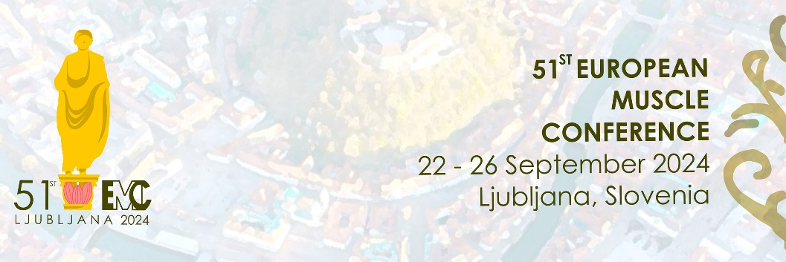Travel award application form

Name (First, Last) __________________________________________________

Affiliation (Institute/University) _________________________­­­________________

Country_______________

PhD student □ Post-Doc □ Years as PhD/Post Doc_______

Previously attended EMC: Yes/No

Indicated preferred type of presentation at the EMC:

Talk □ Poster □ Not presenting □

Please tell us why financial support is needed and how attending the EMC would be beneficial for your scientific career (Please note: this motivation letter will be blinded for evaluation; so please do not include personal information like name, affiliation, etc; limited to 150 words)